Data Description

The quest for New York’s city borough and neighborhood data took me to a web page [1] where I was able to find the required data in JSON format.

The extracted data has the required details to proceed with the analysis. It has got 5 boroughs with 306 neighborhoods’ latitude and longitude details. We will use Foursquare API [2]to search for the restaurants having keyword ‘Restaurant’ in the venue name. We will then use the explore function of Foursquare API to get 10 most common venue categories for each neighborhood. On this k-means clustering algorithm will be applied to group the neighborhoods into clusters and then information will be deduced from each of the derived clusters.

The master data extracted from JSON file has the following main components – Borough, Neighborhood, Latitude, and Longitude. It comprises of 5 Boroughs and 306 Neighborhoods. Head of the data looks like as follows:

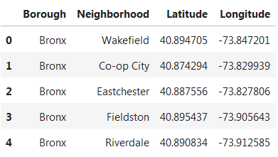

The folium library is used to create a map with neighborhoods superimposed on top.

